# Apply filters to SQL queries

## Project description

With this project we are going to investigate all of the failed login attempts of our company after the hours of 18:00 (6PM), by using SQL commands it will help us organize and view all of our data.

## Retrieve after hours failed login attempts

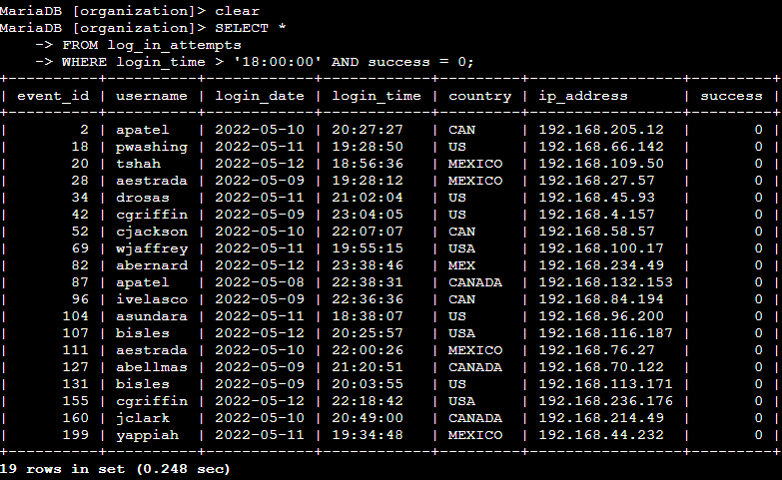

From this screenshot we can see our process of commands in finding the specific data we are looking for. By setting our time to be greater than (>) we will find any attempt that is AFTER the specified value, along with this we also use the AND command to show us only attempts that have a failed success, which is represented by the 0.

## Retrieve login attempts on specific dates

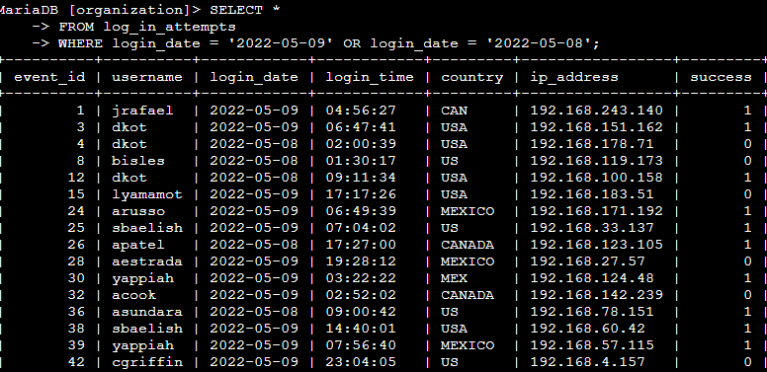

By using the OR command we can make sure that SQL will only show us login attempts on the specific dates that we have given it. With the help of this filtering command we can isolate our incident and comb our information easier.

## Retrieve login attempts outside of Mexico

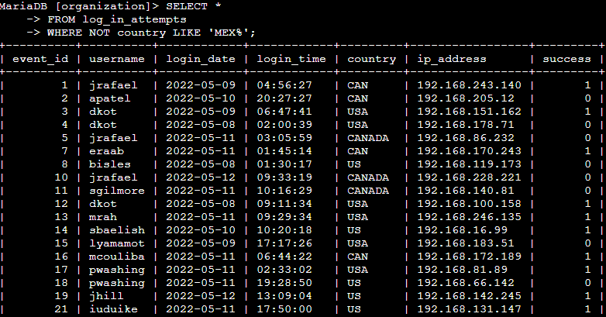

Shown in our image above by using the NOT command after WHERE we can specify that the country column DOES NOT show any country that starts with any keywords that are related to Mex.

## Retrieve employees in Marketing

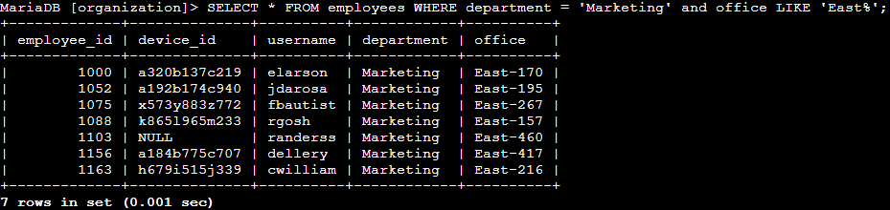

Using what we know about SQL, in our query above we used the WHERE command to specify that we want all the employees that are labeled in Marketing, along with the use of LIKE we want any offices that are in the East wing which is shown by East% (% is a wildcard that searches for anything after the word East).

## Retrieve employees in Finance or Sales

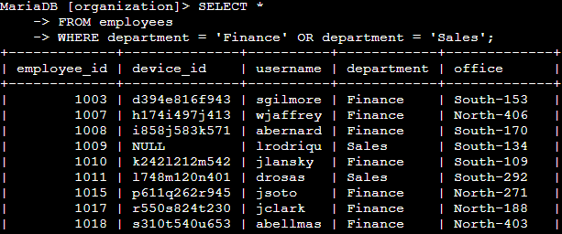

Like we used in our past commands to find employees within the marketing department, all we did for this command was use OR to show we wanted both finance & sales to be included in our results so we can see what employee is in each department.

## Retrieve all employees not in IT

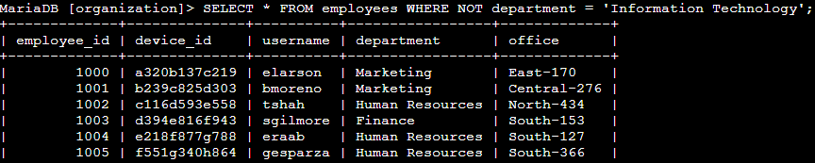

By including the NOT command after where we can make sure that we see every result that doesn’t have anyone labeled in the ‘Information Technology’ tag. By using the NOT command it greatly reduces the amount of queries that we have to do in our search for specific data.

## Summary

In conclusion we can see from all of the screenshots above that filtering in SQL is an extremely powerful tool to have that can help you reduce the amount of time needed, along with making sure that you aren’t receiving results that contain a lot of bloat & overall information that doesn’t pertain to what your query might be.